**Goals:** The goal is to visualize the number of international female football players playing on each positions on the ground in FIFA 2022. From this we will have insights of different playing roles on the field and which playing position is more famous among the players.

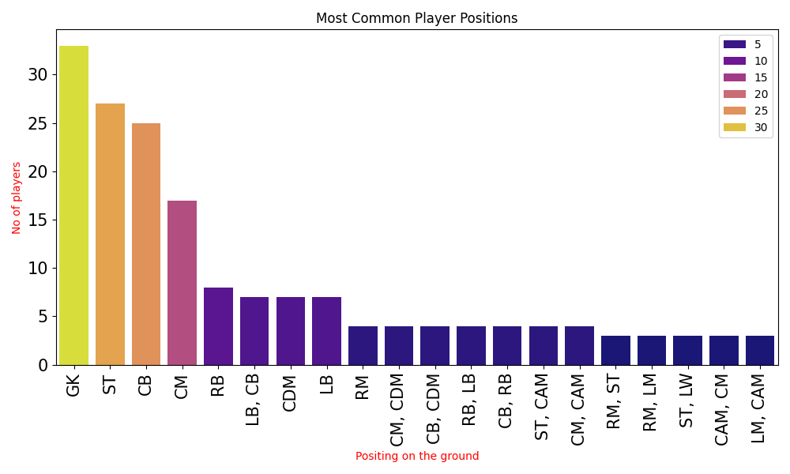

(image)

**Insight:** This bar chart visualization shows uneven distribution of female football players across the ground on different positions like goal keeper, striker, etc. in FIFA 2022. After looking into the bar graph we got to know that there are more than 30 goalkeepers whereas Left midfielder and Central Attacking Midfielders are the lowest in the graph. The above bar plot is taking the first 20 positions on the ground only. By looking into this plot we can identify which playing position needs to be brushed up.

**Data abstraction:** With the use of pandas, I am extracting the player’s position from the data set. After the abstraction of data, I am analyzing and distributing the player’s position. Then visualizing the player’s position with the help of bar plot.

* **Dataset type:** Pandas DataFrame
  + Item: Individual women’s FIFA 2022 players with their associated information
  + Attributes:
    - player_positions

**Task abstraction:**

**Marks:** Bars in the bar plot.

**Channels:** X-axis, Y-axis, and color on the bar plot.

**Users:** This bar plot can be used by analysts or the growing footballers that which playing position is highly in the demand among the world women’s football teams.

**Targets:** Player’s position – This visualization is targeting the player’s position on the ground.

**Actions:** The action for this visualization will be comparing and visualizing the data.

**Additional data source:** [**https://www.kaggle.com/datasets/stefanoleone992/fifa-22-complete-player-dataset/data**](https://www.kaggle.com/datasets/stefanoleone992/fifa-22-complete-player-dataset/data)